



|  |  |  |  |
| --- | --- | --- | --- |
| GEOGRAFIA C  **12.º** Ano  Turma **B** | **FICHA DE AVALIAÇÃO DIAGNÓSTICA** | | |
| Ano Lectivo 2015/2016 | 30 de Setembro de 2015 | Ass. Professor | Classificação |

|  |
| --- |
| Aluno N.º |
| Assinatura do Encarregado de Educação |

**NOTA**: O resultado desta ficha de avaliação não constituirá um elemento de avaliação. A sua elaboração irá permitir ao professor realizar um diagnóstico das aprendizagens realizadas no passado e das dificuldades presentes dos alunos. Constitui um precioso auxiliar do professor para a planificação do trabalho a realizar no presente ano lectivo. Por outro lado, relembra-te das tuas capacidades e lacunas.

**I**

1. Observa atentamente o seguinte mapa e escolhe se as afirmações que lhe seguem são verdadeiras ou falsas.

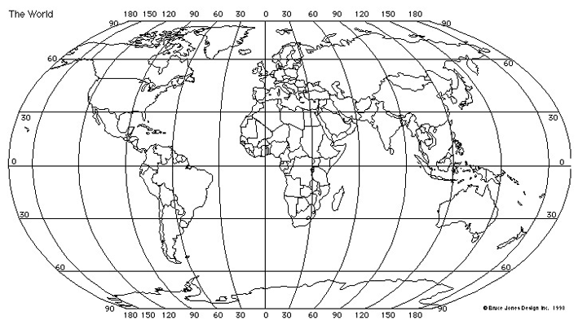

1. O 2.º continente mais pequeno é a Europa. V🞏 F🞏
2. O maior oceano é o Pacífico. V🞏 F🞏
3. O maior país do mundo é a China. V🞏 F🞏
4. O país mais populoso do mundo é a Índia. V🞏 F🞏
5. A maior cidade do mundo é Tóquio. V🞏 F🞏
6. A Antárctida é um continente sem países. V🞏 F🞏
7. A Europa localiza-se a NO da Oceânia. V🞏 F🞏
8. Portugal Continental situa-se no extremo SO da Europa. V🞏 F🞏
9. Portugal localiza-se nas latitudes médias. V🞏 F🞏
10. Portugal Continental localiza-se aproximadamente nos 8ºO. V🞏 F🞏
11. Assinala, aproximadamente, no mapa anterior os seguintes lugares com os números que lhe correspondem:
12. Açores 6. Alemanha 11. Rio Nilo (percurso)
13. Brasil 7. Israel 12. Floresta Amazónica (área com um círculo)
14. EUA 8. Síria 13. Deserto do Sara (área com um círculo)
15. Angola 9. Japão 14. 60ºS/120ºO
16. Egito 10. Indonésia 15. 0º/60ºN

**II**

1. Diz, em poucas palavras, o que significa para ti:
2. “Globalização”.

______________________________________________________________________________________________________________________________________________________________________________________________________________________________________________________________________________________________________________________________________________________________

1. “Guerra Fria”.

______________________________________________________________________________________________________________________________________________________________________________________________________________________________________________________________________________________________________________________________________________________________

1. “ACNUR”.

______________________________________________________________________________________________________________________________________________________________________________________________________________________________________________________________________________________________________________________________________________________________

1. “Fundamentalismo”.

______________________________________________________________________________________________________________________________________________________________________________________________________________________________________________________________________________________________________________________________________________________________

**III**

1. Distingue em poucas palavras:
   1. “Natalidade” de “Fecundidade”.

___________________________________________________________________________________________________________________________________________________________________________________________________________________________________________________________________________________________________________________________________________________________________

* 1. “Pirâmide etária” de “Classe etária”.

___________________________________________________________________________________________________________________________________________________________________________________________________________________________________________________________________________________________________________________________________________________________________

* 1. “PIB” de “IDH”.

___________________________________________________________________________________________________________________________________________________________________________________________________________________________________________________________________________________________________________________________________________________________________

**IV**

1. Diz o sabes sobre o:
   1. “Aquecimento global”.

______________________________________________________________________________________________________________________________________________________________________________________________________________________________________________________________________________________________________________________________________________________________________________________________________________________________________________________________________________________________________________________________________________________________________________________________________________________________________________________________________________________________________________________________________

* 1. “Desenvolvimento sustentável”.

______________________________________________________________________________________________________________________________________________________________________________________________________________________________________________________________________________________________________________________________________________________________________________________________________________________________________________________________________________________________________________________________________________________________________________________________________________________________________________________________________________________________________________________________________

***Bom trabalho!***